Folder Structure:
Week 7
| nodememo
|_user-service
│
├── controllers
│ ├── activityController.js
│ └── userController.js
│
├── routes
│ ├── activityRoutes.js
│ └── userRoutes.js
│
├── app.js
├── db.js
├── package.json
└── .env

db.js
const mongoose = require("mongoose");

const MONGO_URI = process.env.MONGO_URI ||
"mongodb://127.0.0.1:27017/digital_library";

mongoose.connect(MONGO_URI)
.then(() => console.log("MongoDB connected"))
.catch(err => console.error("MongoDB connection error:", err));

const userSchema = new mongoose.Schema({ username: {
type: String, required: true
},
email: {
type: String, required: true
},
profile: {
type: mongoose.Schema.Types.Mixed, default: {}
}
});

const activitySchema = new mongoose.Schema({ user_id: {
type: mongoose.Schema.Types.ObjectId, required: true,
ref: "User"
},
action: {
type: String, required: true
},
timestamp: {
type: Date, default: Date.now
}
});

const User = mongoose.model("User", userSchema);
const Activity = mongoose.model("Activity", activitySchema); module.exports = { User, Activity };

controllers/userController.js
const { User } = require("../db");

const createUser = async (req, res) => { try {
const { username, email, profile } = req.body;

const user = await User.create({ username,
email, profile
});

res.status(201).json({
message: "User created successfully", user
});
} catch (error) { res.status(500).json({
message: "Error creating user", error: error.message
});
}
};

const getUser = async (req, res) => { try {
const user = await User.findById(req.params.id);

if (!user)
return res.status(404).json({ message: "User not found"
});

res.json(user);
} catch (error) { res.status(500).json({
message: "Error getting user", error: error.message
});
}
};

module.exports = { createUser, getUser };

controllers/activityController.js

const mongoose = require("mongoose"); const { Activity } = require("../db");

const createActivity = async (req, res) => { try {
const { user_id, action } = req.body;

if (!mongoose.Types.ObjectId.isValid(user_id)) return res.status(400).json({
message: "Invalid user_id"
});

const activity = await Activity.create({ user_id,
action
});

res.status(201).json({
message: "Activity created successfully", activity
});
} catch (error) { res.status(500).json({
message: "Error creating activity", error: error.message
});
}
};

const getActivities = async (req, res) => { try {
const { user_id } = req.params;

if (!mongoose.Types.ObjectId.isValid(user_id)) return res.status(400).json({
message: "Invalid user_id"
});

const activities = await Activity
.find({ user_id })
.sort({ timestamp: -1 });

res.json(activities);
} catch (error) { res.status(500).json({
message: "Error getting activities",
error: error.message
});
}
};

module.exports = { createActivity, getActivities };

routes/userRoutes.js
const express = require("express"); const router = express.Router(); const {
createUser,
getUser
} = require("../controllers/userController");

router.post("/users", createUser); router.get("/users/:id", getUser);

module.exports = router;

routes/activityRoutes.js
const express = require("express"); const router = express.Router(); const {
createActivity,
getActivities
} = require("../controllers/activityController");

router.post("/activities", createActivity); router.get("/activities/:user_id", getActivities);

module.exports = router;

app.js

const express = require("express"); const app = express(); require("./db"); app.use(express.json());
const activityRoutes = require("./routes/activityRoutes"); const userRoutes = require("./routes/userRoutes");

app.use("/", activityRoutes); app.use("/", userRoutes);

app.listen(5001, () => {
console.log("User service running on port 5001");
});
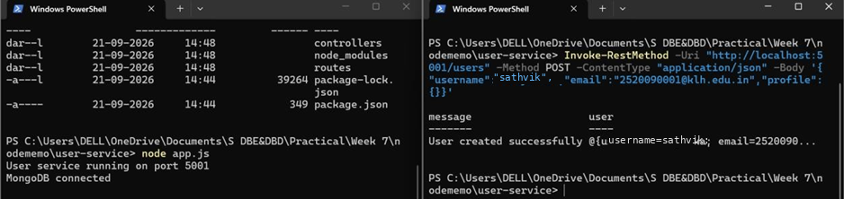

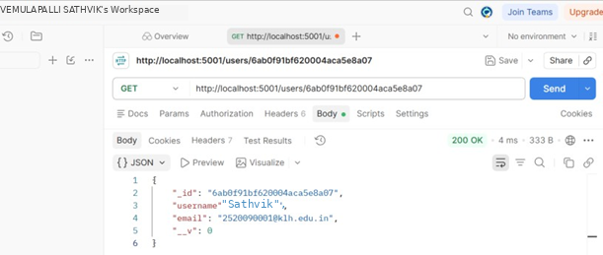

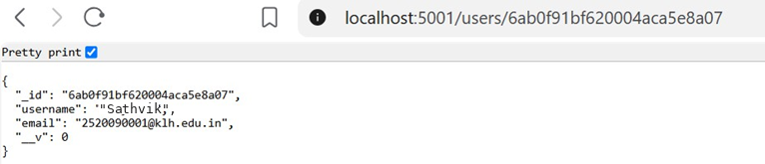
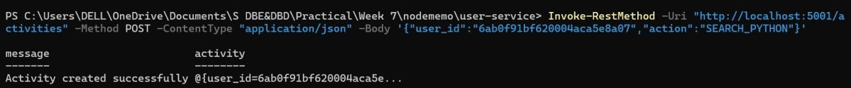

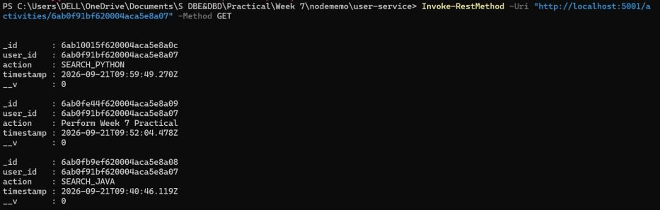

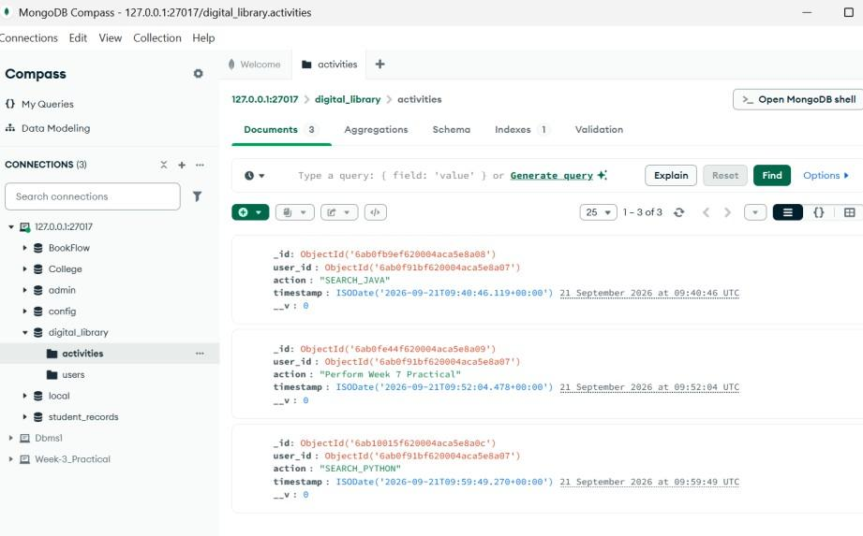
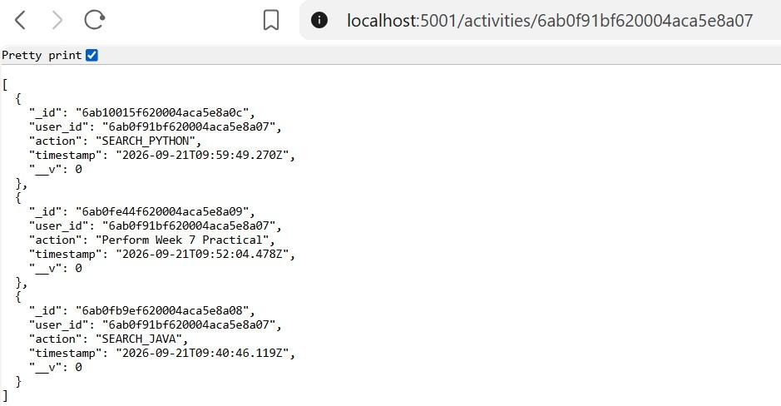
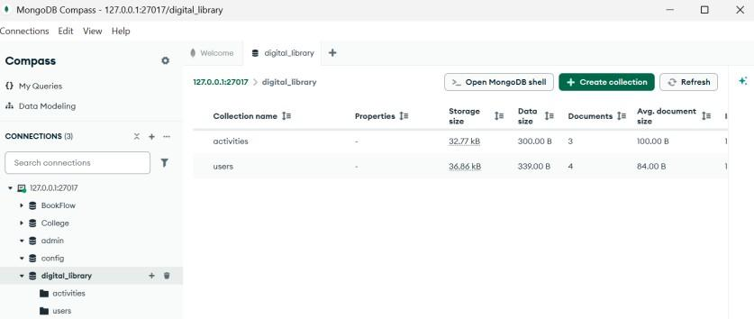

Folder Structure:
Week 7
| nodememo
|_user-service
│
├── controllers
│ ├── activityController.js
│ └── userController.js
│
├── routes
│ ├── activityRoutes.js
│ └── userRoutes.js
│
├── app.js
├── db.js
├── package.json
└── .env

db.js
const mongoose = require("mongoose");

const MONGO_URI = process.env.MONGO_URI ||
"mongodb://127.0.0.1:27017/digital_library";

mongoose.connect(MONGO_URI)
.then(() => console.log("MongoDB connected"))
.catch(err => console.error("MongoDB connection error:", err));

const userSchema = new mongoose.Schema({ username: {
type: String, required: true
},
email: {
type: String, required: true
},
profile: {
type: mongoose.Schema.Types.Mixed, default: {}
}
});

const activitySchema = new mongoose.Schema({ user_id: {
type: mongoose.Schema.Types.ObjectId, required: true,
ref: "User"
},
action: {
type: String, required: true
},
timestamp: {
type: Date, default: Date.now
}
});

const User = mongoose.model("User", userSchema);
const Activity = mongoose.model("Activity", activitySchema); module.exports = { User, Activity };

controllers/userController.js
const { User } = require("../db");

const createUser = async (req, res) => { try {
const { username, email, profile } = req.body;

const user = await User.create({ username,
email, profile
});

res.status(201).json({
message: "User created successfully", user
});
} catch (error) { res.status(500).json({
message: "Error creating user", error: error.message
});
}
};

const getUser = async (req, res) => { try {
const user = await User.findById(req.params.id);

if (!user)
return res.status(404).json({ message: "User not found"
});

res.json(user);
} catch (error) { res.status(500).json({
message: "Error getting user", error: error.message
});
}
};

module.exports = { createUser, getUser };

controllers/activityController.js

const mongoose = require("mongoose"); const { Activity } = require("../db");

const createActivity = async (req, res) => { try {
const { user_id, action } = req.body;

if (!mongoose.Types.ObjectId.isValid(user_id)) return res.status(400).json({
message: "Invalid user_id"
});

const activity = await Activity.create({ user_id,
action
});

res.status(201).json({
message: "Activity created successfully", activity
});
} catch (error) { res.status(500).json({
message: "Error creating activity", error: error.message
});
}
};

const getActivities = async (req, res) => { try {
const { user_id } = req.params;

if (!mongoose.Types.ObjectId.isValid(user_id)) return res.status(400).json({
message: "Invalid user_id"
});

const activities = await Activity
.find({ user_id })
.sort({ timestamp: -1 });

res.json(activities);
} catch (error) { res.status(500).json({
message: "Error getting activities",
error: error.message
});
}
};

module.exports = { createActivity, getActivities };

routes/userRoutes.js
const express = require("express"); const router = express.Router(); const {
createUser,
getUser
} = require("../controllers/userController");

router.post("/users", createUser); router.get("/users/:id", getUser);

module.exports = router;

routes/activityRoutes.js
const express = require("express"); const router = express.Router(); const {
createActivity,
getActivities
} = require("../controllers/activityController");

router.post("/activities", createActivity); router.get("/activities/:user_id", getActivities);

module.exports = router;

app.js

const express = require("express"); const app = express(); require("./db"); app.use(express.json());
const activityRoutes = require("./routes/activityRoutes"); const userRoutes = require("./routes/userRoutes");

app.use("/", activityRoutes); app.use("/", userRoutes);

app.listen(5001, () => {
console.log("User service running on port 5001");
});

